FOR SOCIAL FABRIC-

production, processing and disposal of food. The production is studied in the context of subsistence strategies used by farmers who are engaged in mixed agriculture, especially in the pre-tractor times, ie. until late 1950’s; Food preparation and disposal of food are both activities which are observed in courtyards, within a social setting. The latter provide a physical context in which food related structures (hearths, ovens, pits, storage facilities), as well as associated utensils are recorded.

- In the past kins lived next to each other—making up a large labor force when there was no mechanization, only with human and animal labor—labor intensive—
- transition from oxen to horses to tractor in early 1950’s....most of the grazing land was converted to farming...
- Labor sharing, equipment sharing (selector, dibek,
- Division of Labor - It used to be that doing this was a communal affair, young men beat the bulgur and women did the sieving and washing and drying in early fall, they helped each other, it was a festive time..foods were communally prepared by girls and women and eaten; sweets were eaten; people sang songs and helped each other..it was the past..Following the harvest, the heavy rhytmic sound of the tokmak still go through my ears...two , three of more people used to beat it at the same time, but one at a time...
- Village endogamy; émigrés married similar across villages
- Socio-economic influence of the Excavations
- The related families lived near each other so as to form cooperative labor units. (But now most of them don’t cooperate, with the exception of Köseoglu, Coban and a few others.)

- The floor of the buildingis itself very soft, with no evidence of cooking or heating facilities. Structuralconsiderations suggest that this lined pit was a 'cellar' or undergroundroom ratherthan a'pithouse'.

Among the present strategies, of primary importance is the sensitive scheduling of the agricultural and herding cycles. The rhythm of activities from preparation of fields, planting, weeding harvesting, fallowing to the transport of the crops which run parallel with herding activities from the birthing of lambs, shearing of wool to processing of milk require meticulously calculated scheduling and organization of labor. While the annual cycle of herding activities continues without interruption, the farmers' work slows down during the months of January-February.

One strategy early farmers used (till 1952), was to farm small plots of land in close proximity to each other, so that they rounded up a large tract of land for themselves (bir ciftci genis bir alanı kendisine kapattı).

Others are, (1) planting crops according to soil quality (e.g. barley and cumin "like" clayey soil); (2) mixed farming, with primary emphasis on agriculture; (3) irrigation priority given to cash crops, (4) crop alternation and fallowing, (5) finding new regional markets .

ovens, hearths, storage bins, pits, other installations in courtyards)

The broad picture which emerges from the ethnographic survey of two
seasons is that villages in the 5-20 km. vicinity of YH constitute a
network of settlement complexes of varying sizes, and with varying agricultural/herding potentials. As a whole, they might have provided a rich subsistence base to sustain the Phyrgian center.
While quantitative data on land use and productivity from YH is being examined, I still need to collect such data from the three adjacent villages and study late 19h century historical documents on farming in the region.

The second component of the research, a survey of the courtyard structures and activities, revealed intriguing data which would have direct archaeological implications. That is, put into archaeological context, the size and nature of courtyard structures and the day-to-day activities in them which I have documented may be used to address several archaeological questions among which are, the process of debris accumulation, relative intensities of farming and herding activities, ethnic variation among village settlements, and their material correlates.
I noted that not only oven, “tandır” and hearth types vary between YH village and the two immigrant villages where ethnic Turks from Bulgaria and Greece live, but also in the plan and use of space of their courtyards.
( It must be mentioned that there are, also, some subtle differences in food utensils, ingredients and preparation of food.)
Another significant feature is the size and complexity of plan of sheepfolds located in a courtyard which indicate the intensity of herding practised by that HH. In and immediately outside of most courtyards, there are piles of dung cakes, ash from hearths, hay stalks, piles of unused mudbricks. But only in the herders’ courtyards I have noted piles of carcasses and isolated sheep bones.
I further documented an interesting variation in the location of animal pens between the two immigrant villages and YH village: that the former build animal pens outside the courtyard which are a few hundred meters from their houses, while at YH these installations are within the confines of the courtyard. While courtyards of the immigrant villages are frequently swept frequently, left without any trace of debris, the “native” village courtyards of YH had large piles of fallen bricks, animal droppings, ash and food residues, materials which would be preserved in an archaeological context.

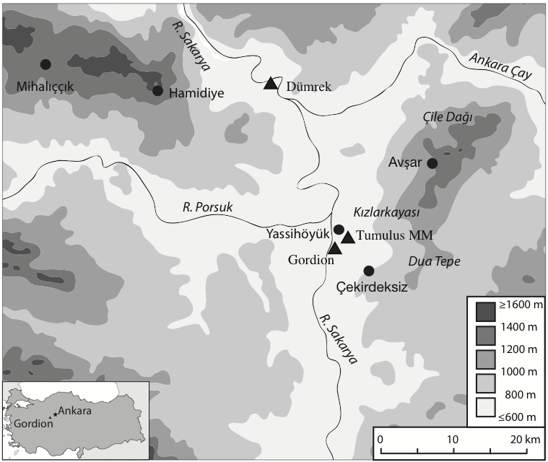

ADD TO GORDION NOTES:

In the past upland herding strategies were complex and labor intensive; an 82 year old shepherd described the traditional practice at ÇK village:
“From 1945 to 1965, herding was very lucrative, the village herd numbered about 15,000 sheep and goats. The flocks grazed for 10 months. We separated the herd into 2 groups of non-milking and milking: non-milking group (yoz) stayed with one shepherd in Kızıllı plateau for the entire 10 months, from March to end of December. Milking ewes and does were separated from the flock during May 15 – August 15, and taken daily to the village grazing lands by a second shepherd. The latter were milked twice daily, and stayed near the village. After milking was finished in Aug. 15, milking ewes joined the yoz group till end of December. For two months in winter the herds stayed in sheds near the village (outside the home CY, in a separate place), and periodically were taken out, while being fed at home. Birthing was during January through May. Recently we are keeping the rams together with sheep all the time”. (M. Y., pers. com. September 1998).

